Master project: Adaptive legged robot
At the ROBIN research group artificial evolution is currently used for optimizing both robotic gaits and robotic morphology (shape).
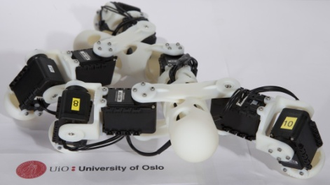
Hypothesis: Physical adaptation of geometrical parameters such as leg lengths during the learning process is excepted to increase the performance
The term performance can be discussed/defined by the student. No such robots are currently available in this framework. In this master project the student will investigate this hypothesis by building a physical adaptive robot and running either an evolutionary gait optimization or a local search based gait optimization process on it. A first (probably non-working) sketch/version of an adaptive legged robot will be available as a SolidWorks CAD model.

Plan for the project:
1) Literature search
2) Writing of essay. This can be considered to be the introduction and a coarse background of the master thesis.
3) Investigating the provided first CAD version/sketch and deciding if it is to be 3D printed directly or with modifications
4) Several CAD / 3D printed (or laser cutted) versions of the robot must be made and evaluated
5) Programming of test gaits / test adaptations (for example in Java/Processing or C++)
6) Interfacing the program to the 3D motion tracker system for measuring the gait performance (fitness function)
7) Evolutionary or local search experiments by either
a) Running local search (hill climbing) combined with a fixed gait on the physical robot as a step in verifying the hypothesis
b) Running the ROBIN evolutionary framework directly on the robot to verify the hypothesis
8) Conclusions
1-8) Writing of the thesis should be done continuously during the project
Hardware:
* Dynamixel servos
* Stepper motor or geared DC motor or complete linear motor system
* 3D printer / laser cutter
* 3D motion tracker system
* Other hardware/electronics may be used if necessary

